Use this reference to change your preferred name.

INSTRUCTIONS

- Log into Workday and enter the Academics app.

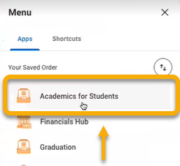

- Click the “Announcements and Forms” tab.

- In the right-hand toolbar, click “Change My Preferred Name”.

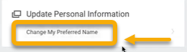

- The Change My Preferred Name page will appear. Locate the Use Legal Name as Preferred Name check box.



If the box is checked, then your legal name will be used as your preferred name. If you do not want to use your legal name as your preferred name, uncheck the box and proceed to step #5.

If the box is unchecked, then you already have a preferred name. To change your preferred name, proceed to step #5.

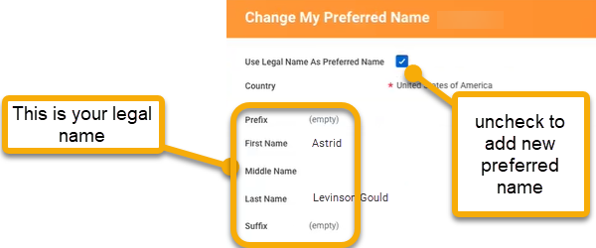

- When the box is unchecked, empty fields will appear. Complete fields to reflect your preferred name.

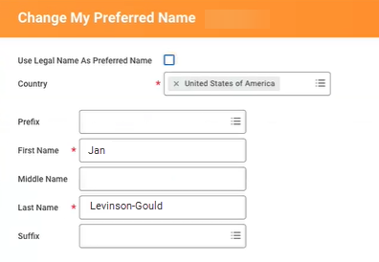

- Click “Submit”.

